Cheerleading Tryouts

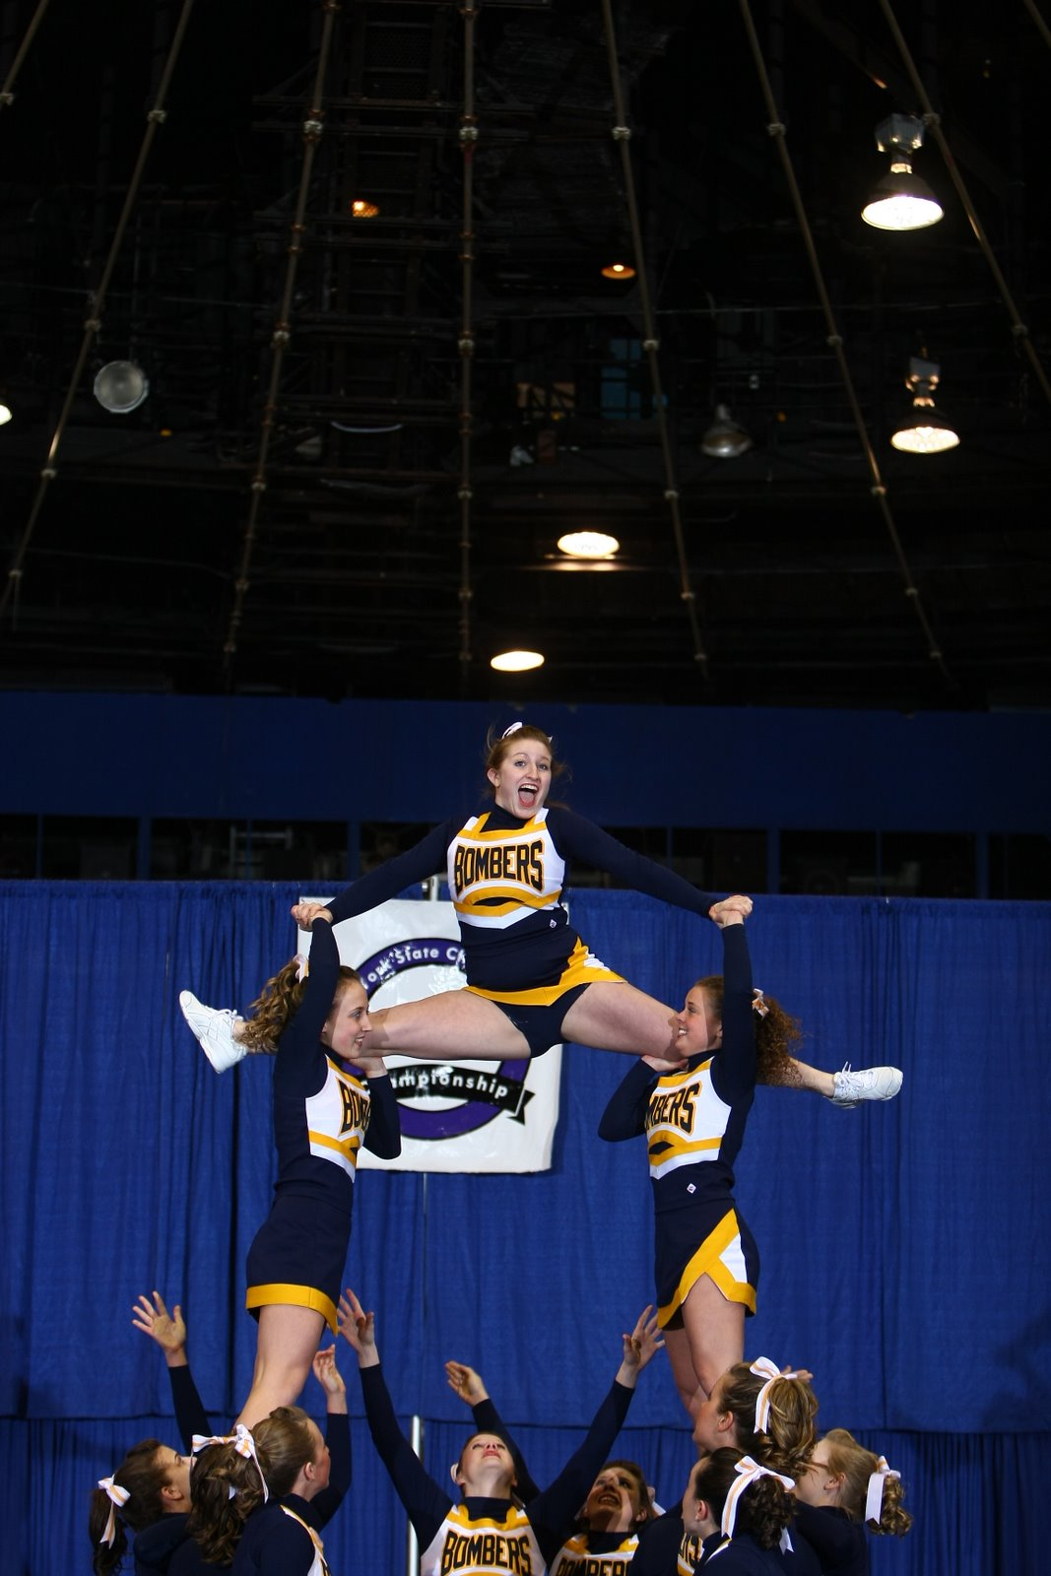
Mandatory Info Meeting
Friday, Aug 28th - 4:00-5:30pm
Williams Hall - Room 317

Tryouts
Saturday, Aug 29th - 10:00am-3:00pm
Hill Center - Gymnastics Room
-and-
Sunday, Aug 30th - 10:00am-1:00pm
Hill Center - Gymnastics Room

Tryouts will be held over a two day span. The first day the material will be taught and
perfected. The second day the material will be reviewed and the tryout will take place.

Any questions? Contact Jessica Sharkey at president@iccheer.com
For more details, visit http://www.iccheer.com
Sponsored by IC Recreational Sports

